- Docker pull nginx:alpine
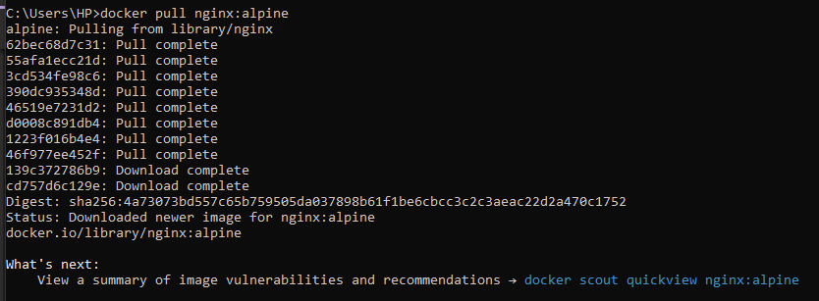
- Docker images
3.1. Docker images inspect ID
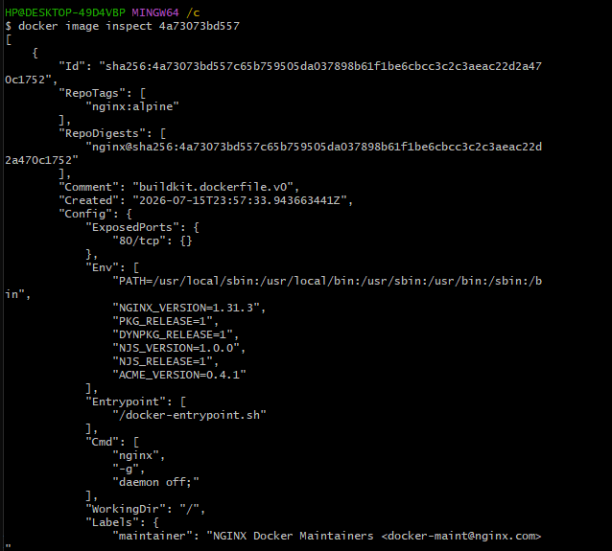

3.2. Docker images inspect NAME
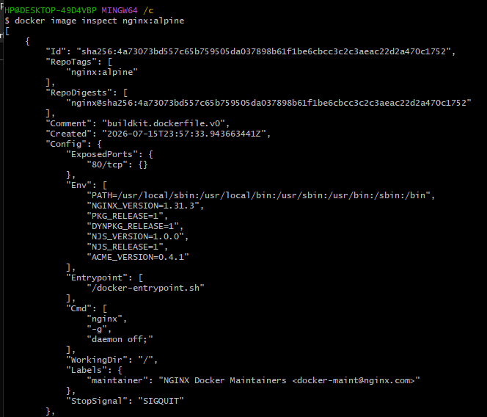
4.1. error comandos
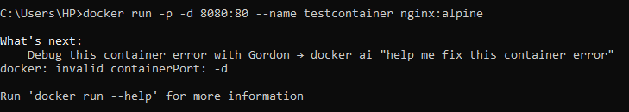
4.2. Docker run (successful)
5. Docker ps
6. Docker logs testcontainer
